Glow Aesthetics & Wellness Studio

Pre-Treatment Instructions

- If possible, do not take Aspirin or other blood thinners 5-7 days before the procedure to prevent bleeding and flushing out pigment. Non-Aspirin pain relievers may be taken up to one hour prior to the procedure. Those who are on blood thinners or certain medications may not be a candidate or may need a doctor’s note to approve procedure.
o **IMPORTANT note: DO NOT discontinue any medications that are prescribed by a Physician or which are necessary for your health.

- Microblading will not be performed on those who are pregnant.

- We will NOT provide microblading to anyone under the age of 18

- Avoid alcohol and ANY caffeine 24 hours prior to the procedure to prevent bleeding. If you consume either of these, you may need additional appointments to retain pigment
- If you have a condition that requires you to take antibiotics before a dental visit, you must check with your doctor to determine if antibiotics are needed for permanent cosmetics.

- Hair removal before your appointment is not recommended. I like to see how your eyebrows naturally grow in to get a perfect brow mapping. I do clean up the brows during/after the procedure.
- Botox and skin plumping injections such as Juvaderm may alter the shape of your permanent cosmetics. You may still get them but you must wait at least 2 weeks before and after getting any injectables to do Microblading.

- Skin treatments such as Retin-A that thin the skin in the procedure area must be discontinued for at least 30 days prior to the procedure. Check with your Dermatologist about specific medications.
- Accutane users must be off Accutane for at least ONE FULL YEAR!!

- Microblading cannot be performed over fresh sunburns, including those caused by tanning beds, or being in the sun during the summer. You must wait until the burn heals. It is advised to avoid tanning even after healing to maintain your brow pigment. If you tan frequently, it is NOT recommended to get microblading done as your pigment will fade, blur and change colors over time.

- I request coming to your appointment with your brow makeup on. I do this so I can gauge how you prefer your brows. This also shows me darkness, shape and thickness that you like. If you can find photos of brows that you prefer, I ask that you bring these in or keep them on your phone so we can evaluate if they are something your face and bone structure would match with but keep in mind that there is no guarantees with microblading.

Glow Aesthetics & Wellness Studio

Post Treatment Instructions
Congratulations on your new Permanent Cosmetics! Please follow these instructions to ensure proper healing and maximum color retention. Remember that colors appear darker and more sharply defined immediately after the procedure and for a few days after. As the healing progresses, color and edges will soften. There are no guarantees and with microblading results but we always strive to give you the very best results for your brows!
You should wait to interpret final results until the healing and touch up is complete. A touch up procedure will be necessary to refresh the color and fill in any places that do not take. If you do not book and complete your 8-12 week touch up, then you are failing to complete the process and will not be satisfied with incomplete results. Failure to follow post treatment instructions may cause loss of pigment, discoloration, and or infection. Although rare, there are some skin types and clients that will require a 3rd touch up at additional cost.

- For the 1st 24 hours after the procedure, you want to remember the word ABSORB! You need to dab your brows by pressing firmly to absorb all oils every 10-30 mins for the 1st 24 hours while awake. You will continue to DAB, DAB, DAB to absorb as frequently as you can for the 1st 2 days after procedure. You may not see any oils, but it is still VERY important to reduce the amount of flaking you have and to promote retention of color! Press firmly.
- Before bed on the night after procedure, you will clean the brows by: taking a q tip with provided cleanser and lightly do circular cleaning on the skin of the brows to remove any dried exudate off your skin. Don’t be afraid to use firm pressure but NEVER RUB! This will allow the tissue to heal more quickly. Pat completely dry. No moisture should remain on the brow. Follow with a VERY TINY amount (size of grain of rice) of after care ointment/grapeseed oil and press in skin, do not rub. It should not be visible on brows. For the next 7 days, please follow this protocol of washing, drying and applying ointment 2 times per day and dabbing with dry cloth to oil absorb frequently. Always make sure your hands are clean 1st. Those with very oily skin should avoid ointment unless very dry and itchy and should oil
absorb by dabbing as frequently as possible for the 1st 3 days.

- For the first few days your Microblading will appear to be darker and bigger/thicker then they will heal. Your color will also be very WARM toned and sometimes have a reddish/orangey tint until it cools down. It takes approximately 1 week for the brows to cool in color. Do not panic. Final color result cannot be determined until you are fully healed. Around 5-10 days you will start to see fading and condensing of the eyebrow area. On AVERAGE there is a 40% loss of pigment after the procedure which is why the touch up is essential. Then color boosts are recommended around 1-2 years with most people wanting a touch up around 1 year. Machine microshading tends to last longer, closer to 2 years. Softening of the pigment is normal and to be expected. The brows will heal to a softer, blended, more natural look. Do NOT panic when you go through the stages of healing. Darker, thicker looking brows should be expected for the 1st few days until the healing process begins.

- It is normal for some people to have pigment scab or flake off. It is also normal if it does not (lucky you). Scabby/flakey brows WILL happen for most clients. It is normal. Fading or loss of pigment may occur during healing. It may take up to a few months for the pigment to completely re-flourish. The color will look like it had disappeared as scabs come off. That color will resurface a bit over the next few weeks. We will reinforce the spots that didn’t take as well at your touch up. Do NOT touch, pick, rub or scratch the scabs! To reduce the amount of flaking/scabbing, it is ESSENTIAL for you to dab firmly (not rub) to absorb oil frequently the 1st 3 days, follow post care and do not get them wet. Avoid sleeping on belly or side if possible. Your brows have not disappeared after the flaking stage! It takes up to a full month to see the color come back and that is why the touch up is essential. The color comes back lighter and blended, but you must give your brows time to heal to assess the final look. There are no guarantees for your brows, but I do everything I can to ensure you get the most beautiful brow shape and color to fit your personality, facial structure, tones, and personal goals.

- See pictures below for what to expect with flaking/crusting, though it may be less or worse depending on how your body heals.

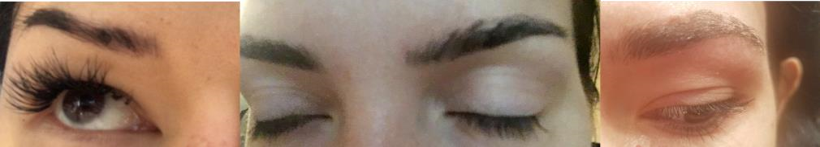
- Pigment may come off on your pillow while you sleep, and may stain linens. Use a clean cover that you won’t mind staining if this happens.

- Stay out of the sun. If you must be outside, wear a hat and sunscreen. After the procedure heals, use sunscreen of SPF 50 to prevent future fading of pigment color. No SPF until healing is done. No other lotions or ointments.
- Ice may be applied the first day following the procedure for 10-15 minutes. Use a clean cloth to cover the bag to avoid condensation on your freshly microbladed brows. Brows will feel sunburned for up to 48 hours.

- Avoid exercise that causes sweating until the procedure heals (around 10 days). If you sweat, you will push pigment out and color will not stay! ZERO EXERCISE if you want your pigment to stay! Salt removes color!!!! Sweat=pigment disappearing.
- Avoid contact/submersion with water (pools, shower, etc) in the procedure area until healed. The possibility of water flushing out the pigment within the first two weeks after procedure is high. If a small amount of water gets on your brows in the shower, that is ok. Just dab dry and avoid letting shower head hit your brows until healed. Face away from shower, keep baths short and do not splash water on your face. You can resume getting your brows wet after scabbing/flaking is complete.

- For the first few weeks you will want to wash ONLY around the microbladed area. You can “clean” the area by using provided cleanser.
- DO NOT rub the procedure area while it is healing, pigment may be removed prematurely along with crusting.

- After crusting has naturally sloughed off you can GENTLY wash the area. Everyone is unique in their skin type and it is not just one cleanser that works for everyone. Avoid anti-aging cleansers or exfoliating products in the brow area.
- Avoid makeup, lash/brow tints and other facial treatments until the procedure heals (around 10 days). Very gentle facial washes and treatments are acceptable after 24 hours as long as the procedure area is avoided.

- To prevent infection, I ask that if you have any pets, that you are not allowing them to lick/sit/paw at your microbladed area. Keep hands off of the brows while healing as they carry bacteria. ALWAYS wash hands well before cleaning your brows.
- Avoid any clothing that may irritate the procedure area.

- You may or may not be allowed to give blood for 1 year following procedure depending on your state.
- Symptoms of infections or adverse reaction are very rare but it is important to know the signs and report immediately if present to your physician. They include: excessive redness, swelling, tenderness of procedure site, elevated body temperature, rash or purulent drainage from the procedure site. If you experience symptoms of infection or adverse reaction, seek medical attention immediately. o **Please note that some redness, swelling, and tenderness is normal unless it continues for more than 3 days.
- Touch ups should be scheduled about 8-12 weeks post procedure. All permanent cosmetic procedures are a 2-step process. Results are not determined until a touch up application is completed. If you do not get your touch up, your appointment will be considered a color boost/redo and you will not be charged for touch up price. You must complete the procedure. No refunds for services. Book your touch up online under 8 week touch up. Although rare, it is possible some clients will need a 3rd appointment to achieve desired results.
o See pictures below for reference on healing versus healed microbladed brows.
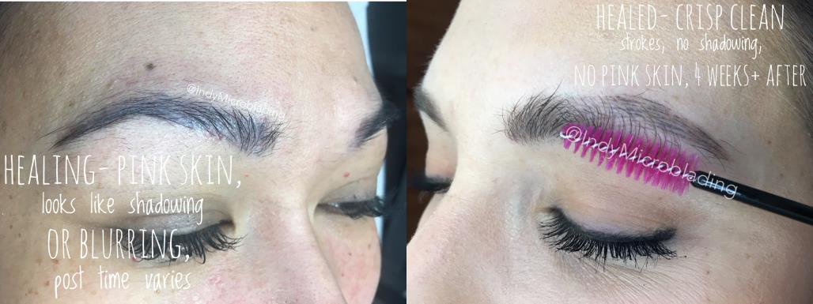
• Here’s a meme of what’s expected emotionally of your healing phases.
Dates are not exact since everyone heals at a different rate.

