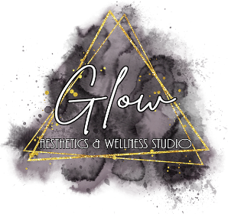

Botox Cosmetic™ Post Treatment Instructions
Botox Cosmetic™ treatment involves the injection of highly diluted, individualized doses of botulinum toxin A into (or in close proximity to) overactive facial muscles or sweat glands, which are responsible for wrinkles or excessive sweating respectively. Botox® relaxes muscle(s) and/or sweat glands by diminishing their ability to contract.

- Exercise your treated muscles by performing 10 contractions every 15 minutes for three hours.
- It is important NOT to rub or massage the treated areas for 24 hours following treatment.
- Do not lie down or do strenuous exercise for three hours after treatment.
- It is possible that you may experience a headache and/or flu-­‐like symptoms for approximately 24-­‐48 hours. Acetaminophen (Tylenol) may be taken for relief only.
  - Do not take aspirin containing products, Ibuprofen, Motrin, Aleve, Vitamin E, or Fish oil for the next 24 hours. These agents may increase bruising/bleeding at the injections site.
- It is best to avoid alcohol intake beyond a single drink, glass of wine, or beer for approximately 24 hours post-­‐treatment.
- The redness and marks on the treated areas will likely disappear within a few hours after treatment. There is a slight risk of bruising that may last up to one week. This is always temporary and can be treated with Arnica, which is available for purchase or at most health food stores and is safe.
- Botox Cosmetic™ can take up to two weeks for full effect. If you feel that you would desire more relaxation of the muscles treated, we will address this at your two week follow up appointment.
- Results may vary. If there is partial improvement of a treated site, and re-­‐treatment is desired, a second treatment may be performed. There is a subsequent charge for any subsequent treatments.

Your follow up appointment is scheduled for .

- Botox Cosmetic™ requires a special technique in order to customize the injections to your individual muscular structure. Therefore, over the next few months, it is important that your muscle activity recovers but that your skin is not creasing to the point from where you started.
- Botox Cosmetic™ is a temporary procedure and at first, you may find that your treatment results will last approximately 3-­‐4 months. If you maintain your treatment appointments with frequency recommended, the duration of each treatment result may last longer than 4 months.
- To achieve optimal results, you will need to repeat Botox ® treatments when you notice recurrent muscle activity and crinkling of the skin.

Your next treatment is scheduled for .
If however, the muscle activity and fine crinkling recurs prior to your next treatment date, please contact us for an earlier appointment.

Glow Aesthetics and Wellness Studio, LLC www.glowaestheticsandwellnessstudio.com

